Lab: Provision Your First Infrastructure on Azure with Terraform

Learning Objectives
By the end of this lab, you will be able to:
- Write and execute Terraform scripts for Azure infrastructure.
- Authenticate to Azure using the Azure CLI.
- Create and configure an Azure Resource Group with Terraform.
- Understand key Terraform commands and workflow.

Pre-requisites
Make sure you have the following before starting:
- A valid Azure account with an active subscription.
- Terraform installed locally.
- Azure CLI installed locally.
- Visual Studio Code (VS Code) or any IDE installed.
If you haven’t completed these, please go through the previous lab on Terraform setup.

Authentication and Authorization
Terraform needs to authenticate with Azure to create resources. There are multiple ways to do this, but in this lab, we’ll use the Azure CLI method.

Run the following command in your terminal:
az login

This will open a browser window where you can enter your Azure credentials.
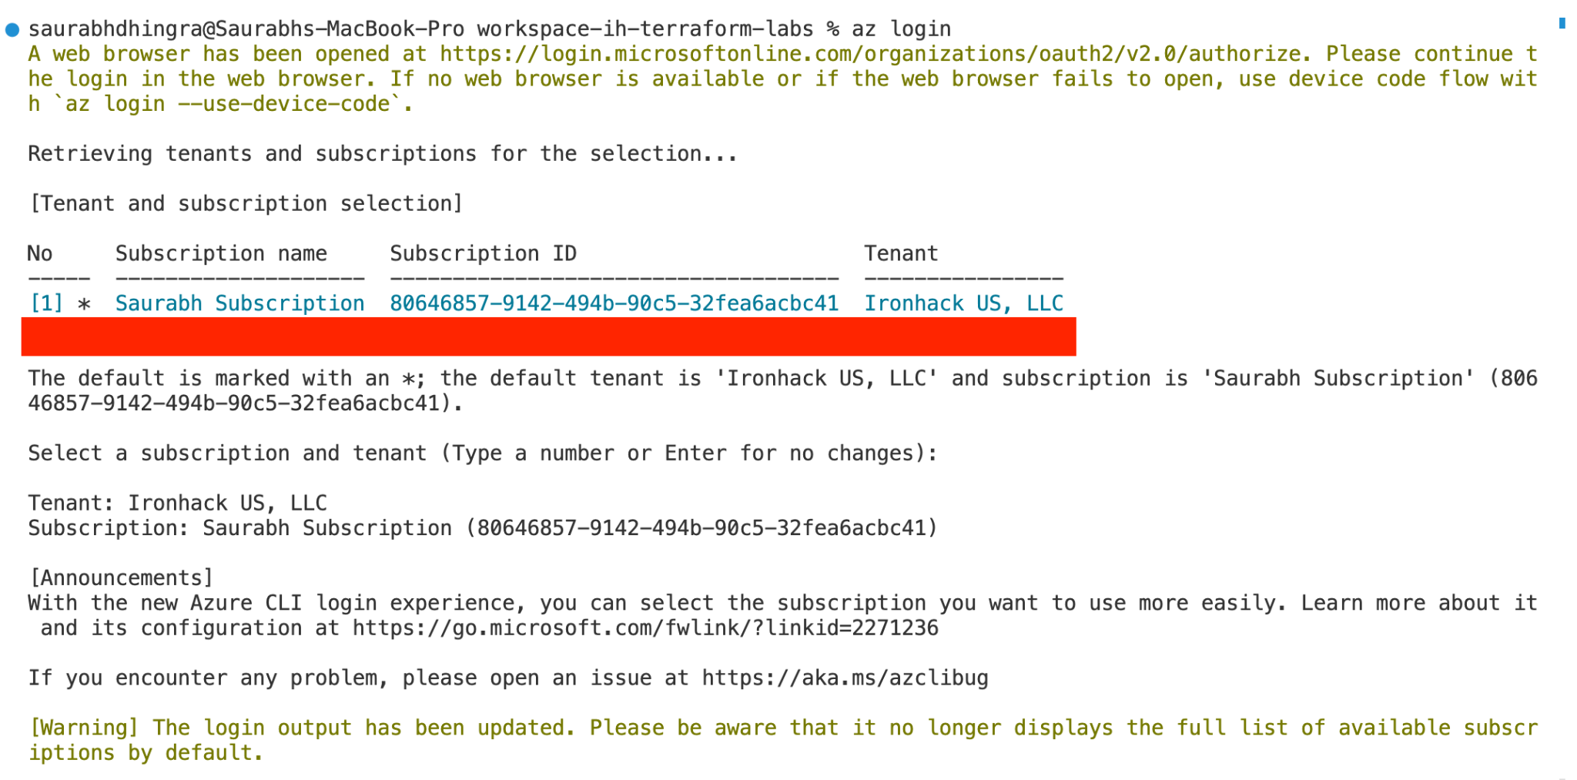
If you have multiple subscriptions, select the one you want to use:
az account set --subscription "<your-subscription-id>"

To get your subscription ID, run:
az account list

Step 1: Create Terraform Configuration Files

1.1 Create Project Folder
In VS Code, create a new folder called resource_group. This will be your Terraform root module.

1.2 Configure the Provider
Create a file named providers.tf and add:
terraform {
required_providers {
azurerm = {
source = "hashicorp/azurerm"
version = "4.26.0"
}
}
}
provider "azurerm" {
features {}
subscription_id = "<your-subscription-id>"
}

Explanation:
- terraform block → sets required providers and versions.
- provider "azurerm" → tells Terraform to use Azure.
- features {} → required by AzureRM provider (even if empty).
- subscription_id → tells Terraform which subscription to deploy to.

1.3 Initialize Terraform
Run:
terraform init

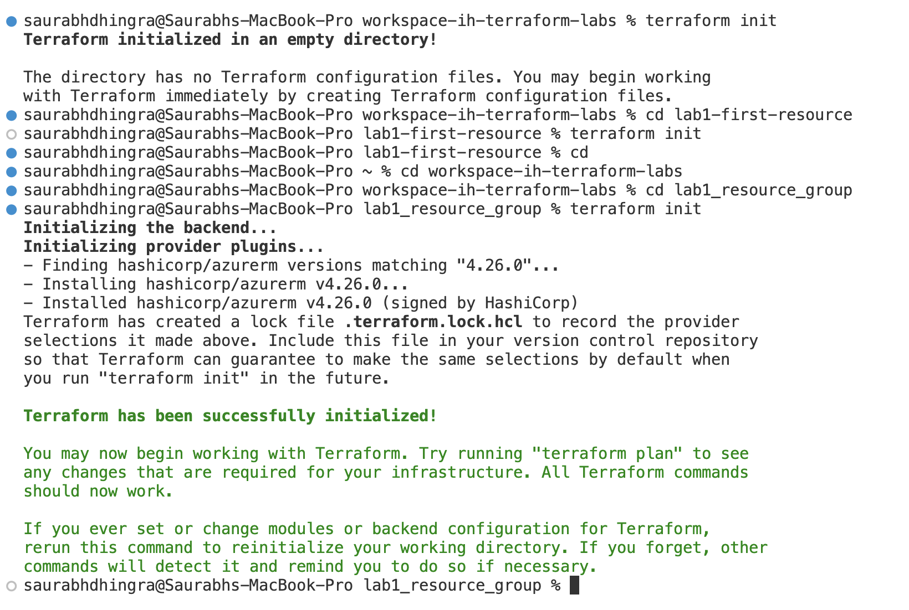
This will download the required Azure provider and create .terraform and lock files in your folder.

1.4 Define Variables
Create a file named variables.tf:
variable "resource_group_name" {
type = string
description = "Name of the Resource Group"
}
variable "location" {
type = string
description = "Azure region where resources will be created"
default = "West Europe"
}
variable "tags" {
type = map(string)
description = "Tags to assign to resources"
}

1.5 Create Resource Group
Create a file named resource_group.tf:
resource "azurerm_resource_group" "resource_group" {
name = var.resource_group_name
location = var.location
tags = var.tags
}

1.6 Add Variable Values
Create a file named terraform.tfvars:
resource_group_name = "rg-terraform-vmlabs"
location = "West Europe"
tags = {
environment = "dev"
}

Step 2: Run Terraform Commands
Format your code
terraform fmt
- (Makes the code clean and readable.)
Validate configuration
terraform validate
- (Checks syntax and catches errors.)

Preview changes
terraform plan
- (Shows what Terraform will create in Azure.)
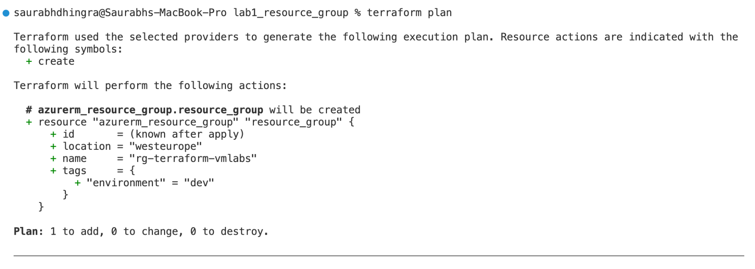
Apply configuration
terraform apply --auto-approve
- (Actually provisions the Resource Group in Azure.)
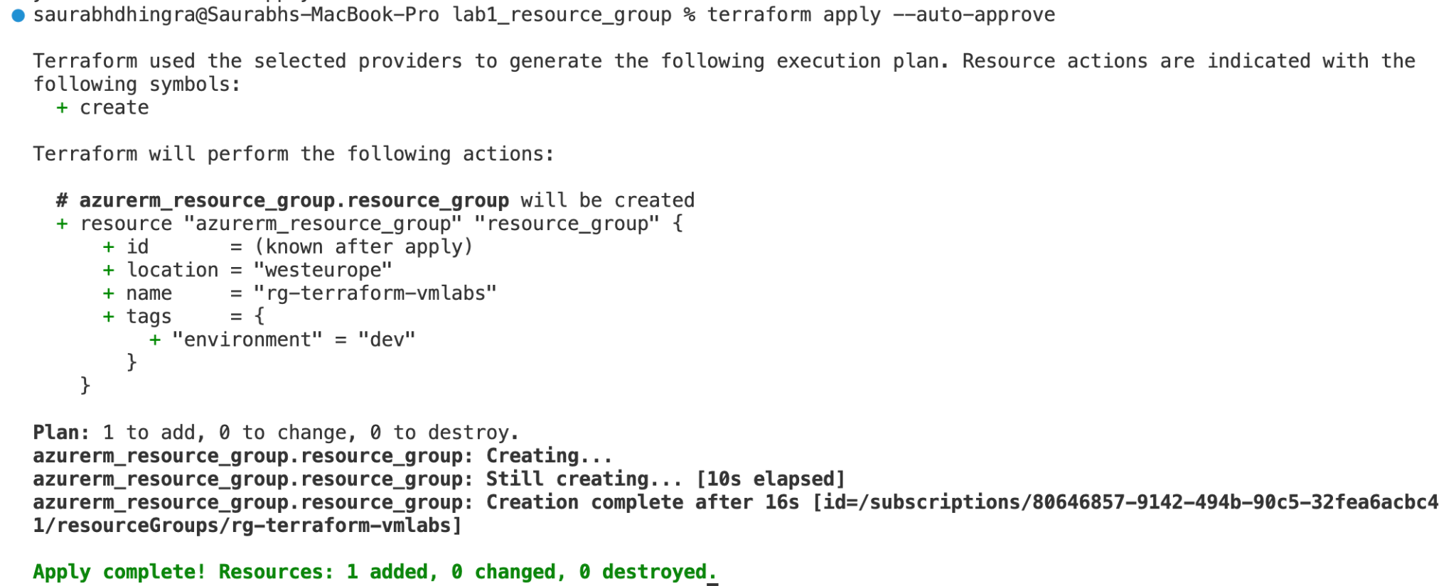
- Verify in Azure Portal
Log in to Azure Portal, navigate to Resource Groups, and confirm your new rg-terraform-vmlabs exists.

Step 3: Clean Up (Destroy Resources)
To avoid unnecessary costs, delete the Resource Group by running:
terraform destroy --auto-approve

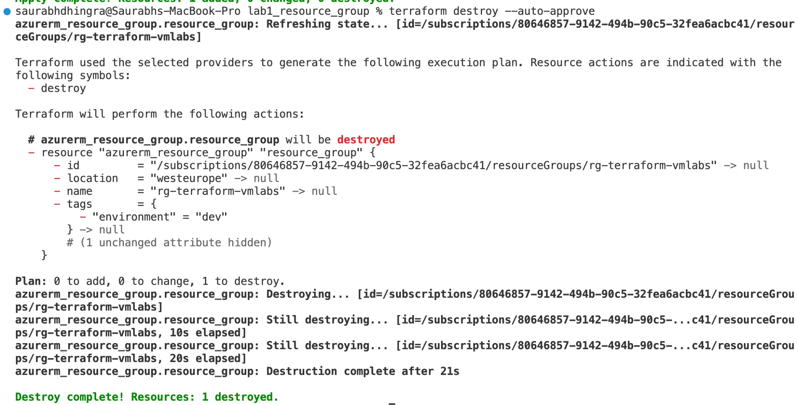

Congratulations!
You’ve just provisioned your first Azure resource (a Resource Group) using Terraform.
You now know how to:
- Authenticate Terraform with Azure.
- Write provider and resource blocks.
- Use variables and tfvars files.
- Run Terraform’s core workflow (init → plan → apply → destroy).
This sets the foundation for provisioning more complex Azure infrastructure with Terraform.

